SUMMER DANCE @ MHBD&TS
Email: Dans821@aol.com P 201-436-0637 Website: Dancehug.com
August 18 – September 3rd

JAZZ – LYRICAL – CHOREOGRAPHY Taught by Meghan Stapenski
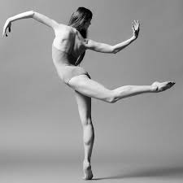
Tuesday Thursday (Age 10 & Up) 1 Class Card 3hrs. $60
3:30-6:30 3:30-6:30 2 Class Card 6 hrs. $110
Aug. 18, 25, Sept. 2 Aug. 20, 27, Sept. 3 3 Class Card 9 hrs. $160
4 Class Card 12 hrs. $210
6 Class Card 18 hrs. $320

BALLET Taught by Kathryn Munoz
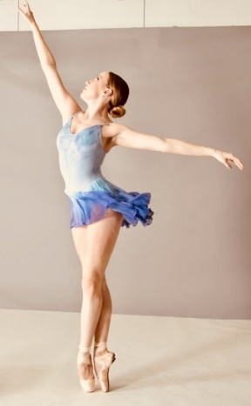
Wednesday (Age 10 & Up) 1 Class Card 3 hrs. $60.00
10:00a.m.-1:00p.m. 2 Class Card 6 hrs. $110.00
Aug. 19, 26, Sept. 2 3 Class Card 9 hrs. $160.00

ACRO Taught by Jennifer Miceli
Tues. & Thurs. (Age 6-9) Tues. & Thurs. (Age 10 & Up)
10:00 – 12:00 12:30-2:30 1 Class Card 2 hrs. $40
Aug. 18, 25, Sept. 2 Aug. 20, 27, Sept. 3 2 Class Card 4 hrs. $75
3 Class Card 6 hrs. $115

NOW TAKING REGISTRATION – LIMITED SPACE – PAYMENT IN FULL UPON REGISTERING – LIVE CLASS
or LIVE VIRTUAL class - nonrefundable

