SUMMER DANCE INTENSIVE
@ MHBD&TS 2021
Email: Dans821@aol.com P 201-436-0637
Space is limited REGISTER EARLY!

JAZZ – LYRICAL – CHOREOGRAPHY- LITE ACROBATICS (Age 10 & Up)
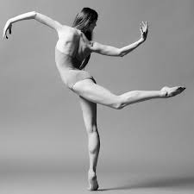
Taught by Meghan Stapenski
Tuesday Thursday 1 Class Card 3hrs. $70
3:30-6:30 3:30-6:30 2 Class Card 6 hrs. $120
July 13, 20, 27 July 15, 22 & 29 3 Class Card 9 hrs. $170
4 Class Card 12 hrs. $220
6 Class Card 18 hrs. $330

BALLET (Age 10 & Up)
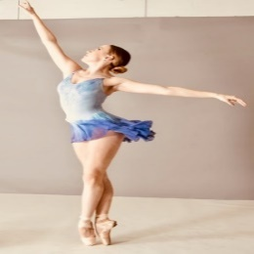
Taught by Kathryn Munoz
Wednesday
July 14, 21, 28th - 10:00a.m.-1:00p.m.

1 Class Card 3 hrs. $70.00
2 Class Card 6 hrs. $115.00
3 Class Card 9 hrs. $165.00

ACRO (Age 7 & Up)
Taught by Coach Jen
Tuesday Thursday 1 Class Card 2hrs. $46
3:00-5:00 3:00-5:00 4 Class Card 4 hrs. $84
July 13, 20, 27 July 15, 22 & 29 6 Class Card 6 hrs. $120

