MHBD&TS
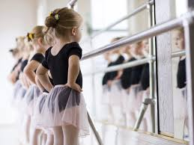
Ms. Huguette’s Broadway Dance & Theatrical Studio - 821 Broadway- Bayonne NJ 07002
E: DANS821@AOL.COM P: 201-436-0637- W: Dancehug.com

AGES 2 – 4: CREATIVE DANCE Wed @ 5:30 pm (5 classes $100)

Summer Dance Camp
Age 4-6 DANCE CAMP
Age 7-10 DANCE CAMP

Tuesday, Wednesday & Thursday
WEEK 1 June 29, 30, July 1
WEEK 2 July 6, 7 & 8
WEEK 3 July 13, 14 & 15
WEEK 4 July 20, 21 & 22
WEEK 5 July 27, 28 & 29

AM ½ Day 9:00-12:00 $144 per week
PM ½ Day 12:00-3:00 $144 per week
Full Day 9:00-3:00 (per week) $252 per week
Per Full Day (drop in) 9:00-3:00 $102 per day
Per ½ Day (drop in) AM or PM $60 per day

EMAIL OR CALL TO REGISTER FOR SUMMER

Bring Healthy Lunch or snack, water bottles with names on them. Classes having fewer than 6 students may be canceled. 03/26/21

