SUMMER DANCE @ MHBD&TS
Email: Dans821@aol.com P 201-436-0637
Space is limited REGISTER EARLY!
(Age 10 & Up)

JAZZ – LYRICAL – CHOREOGRAPHY- LITE ACROBATICS
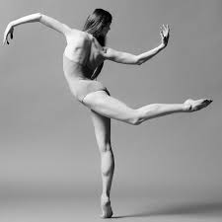
Taught by Meghan Stapenski

Tuesday Thursday SINGLE CLASS 3hrs. $50.00
3:30-6:30 3:30-6:30 2 Class Card 6 hrs. $90.00
July 9, 16, 23 July 11, July 18, 25 4 Class Card 12 hrs. $168.0
6 Class Card 18 hrs. $234.00
BALLET
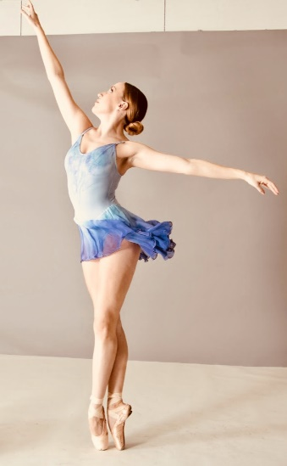
Taught by Kathryn Munoz

Wednesday
July 10, 17, 24th - 10:00a.m.-1:00p.m.

1 Class Card 3 hrs. $50.00
2 Class Card 6 hrs. $84.00
3 Class Card 9 hrs. $117.00

