MHBD&TS
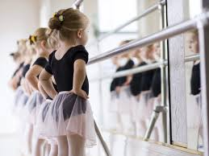
Ms. Huguette’s Broadway Dance & Theatrical Studio - 821 Broadway- Bayonne NJ 07002
201-436-0637- Dancehug.com

3 Yr. Creative Dance Tues & Thurs @ 5:30 pm (9 classes $165)
3 Yr. Creative Dance Wed @ 9:00 am (5 classes $95)

Summer Dance Camp
Dance Camp 1 age 4-6 years
Dance Camp II age 7-10 years

Tuesday, Wednesday & Thursday
June 25, 26 & 27
(Closed July 4) July 2 & 3($85 ½ day, week 2, $170 full day, week 2)
July 9, 10 & 11
July 16, 17 & 18
July 23, 24 & 25

AM ½ Day 9:00-12:30 $125 per week
PM ½ Day 12:00-3:30 $125 per week
Full Day 9:00-3:30 (per week) $195 per week
Per Dance class 9:30-10:30 $20 per class
Per Full Day (drop in) 9:00-3:30 $75 per day
Per ½ Day (drop in) AM or PM $50 per day

Bring your own Healthy Lunch or snack, water bottles with names on them
Dance Camp having fewer than 6 students may be canceled 06/11/19

